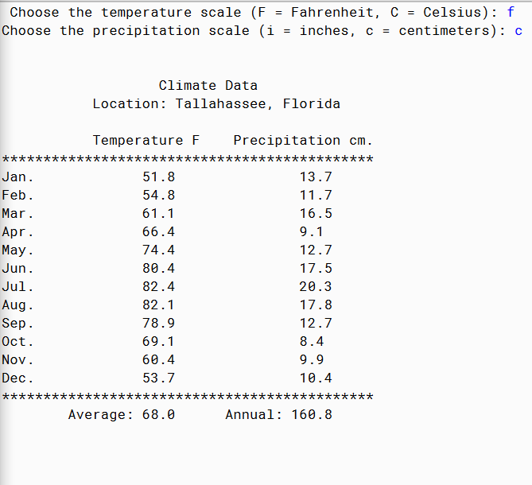

PMR: Recently I felt as though I have been relying a lot on resources from the internet, the notes have become harder and it is harder to learn everything from it. I need to start my work early to finish early and be able to create programs with more help from the solution book.

/\*

\* By Anika Jallipalli

\* 11/2/2019

\* Purpose: Convert Fahrenheit to Celsius and inches to centimeters.

\* PMR in README.txt

\*/

import java.util.Scanner;

public class AnnualClimate2 {

public static void main(String[] args)

{

//Scanner for user input

Scanner in = new Scanner(System.in);

//collect user input choosing the temperature scale

System.out.printf("Choose the temperature scale (F = Fahrenheit, C = Celsius): ");

String temperatureScale = in.next().toUpperCase();

//collect user input choosing the precipitation scale

System.out.printf("Choose the precipitation scale (i = inches, c = centimeters): ");

String precipitationScale = in.next().toLowerCase();

System.out.println();

System.out.println();

//print out title

System.out.printf("%31s%n", "Climate Data");

//climate data

String location = "Tallahassee, Florida";

//in Fahrenheit and inches

double[] temperature = {51.8, 54.8, 61.1, 66.4, 74.4, 80.4, 82.4, 82.1, 78.9, 69.1, 60.4, 53.7};

double[] precipitation = {5.4, 4.6, 6.5, 3.6, 5.0, 6.9, 8.0, 7.0, 5.0, 3.3, 3.9, 4.1};

//alternate climate data for Detroit, Michigan (in Fahrenheit and inches)

/\*

String location = "Detroit, Michigan";

double[] temperature = {22.9, 25.4, 35.7, 47.3, 58.4, 67.6, 72.3, 70.5, 63.2, 51.2, 40.2, 28.3};

double[] precipitation = {1.8, 1.7, 2.5, 3.0, 2.9, 3.6, 3.2, 3.4, 2.9, 2.1, 2.7, 2.8};

//the temperature average should be: 48.6 degrees Fahrenheit

//the annual precipitation should be: 32.6 inches

\*/

//variables

String[] months = {"Jan.", "Feb.", "Mar.", "Apr.", "May.", "Jun.", "Jul.", "Aug.", "Sep.", "Oct.", "Nov.", "Dec."};

double average = 0.0;

double annual = 0.0;

String precipitationMeasurement = "";

//convert to Celsius (if necessary)

if(temperatureScale.equals("C"))

{

for(int i = 0; i < temperature.length; i++)

{

temperature[i] = ((temperature[i] -32) \* 5) / 9;

}

}

//convert to centimeters (if necessary)

if(precipitationScale.equals("c"))

{

for(int i = 0; i < precipitation.length; i++)

{

precipitation[i] /= 0.39370;

}

}

//calculate the average and the annual precipitation

//average

for(int i = 0; i < temperature.length; i++)

{

average += temperature[i];

}

average /= temperature.length;

//annual

for(int i = 0; i < precipitation.length; i++)

{

annual += precipitation[i];

}

//convert the precipitation scale to text

if(precipitationScale.equals("i"))

{

precipitationMeasurement = "in.";

}

else if(precipitationScale.equals("c"))

{

precipitationMeasurement = "cm.";

}

//print everything out to the menu

//print out the location, temperature scale, and the precipitation measurement scale

System.out.printf("%21s%s%n%n", "Location: ", location);

System.out.printf("%23s%-5s","Temperature ",temperatureScale);

System.out.printf("%s%s%n", "Precipitation ", precipitationMeasurement);

System.out.println("\*\*\*\*\*\*\*\*\*\*\*\*\*\*\*\*\*\*\*\*\*\*\*\*\*\*\*\*\*\*\*\*\*\*\*\*\*\*\*\*\*\*\*\*\*");

//print out the data

for(int i = 0; i < months.length; i++)

{

System.out.printf("%-17s%-19.1f%-17.1f%n", months[i], temperature[i], precipitation[i]);

}

System.out.println("\*\*\*\*\*\*\*\*\*\*\*\*\*\*\*\*\*\*\*\*\*\*\*\*\*\*\*\*\*\*\*\*\*\*\*\*\*\*\*\*\*\*\*\*\*");

//print out the average temperature and the annual rainfall

System.out.printf("%17s%-10.1f", "Average: ", average);

System.out.printf("%s%-10.1f", "Annual: ", annual);

}

}